**JIT/JIBE/10603– Collapsible menu and layout Changes**

1. **Introduction**

This is an enhancement to the look and feel of Jibe web application by changing the menu and layout .

1. **About this release**

This new feature will change the login and overall look of the Jibe website y changing horizontal menu to vertical menu and header design of the page.

1. **New Features**
   1. Login page has been newly designed.
   2. Horizontal menu changed vertical with collapsible feature
   3. All styles in menu selection has been changed.
   4. Menu selection persists after refresh.
   5. Breadcrumbs has been added on header
   6. User setting and help menu styles changed
2. **Menus / Access Rights added or removed**

N/A

1. **Improvements/Enhancements**

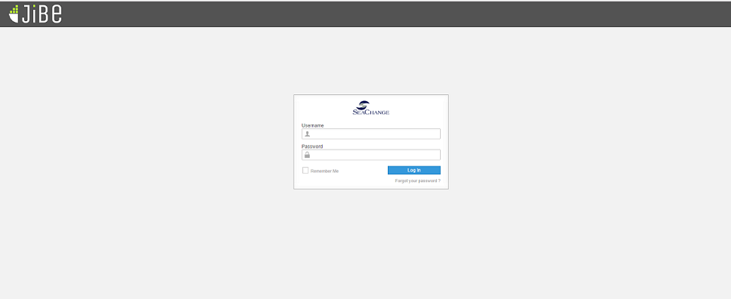

**Fig: Login screen**

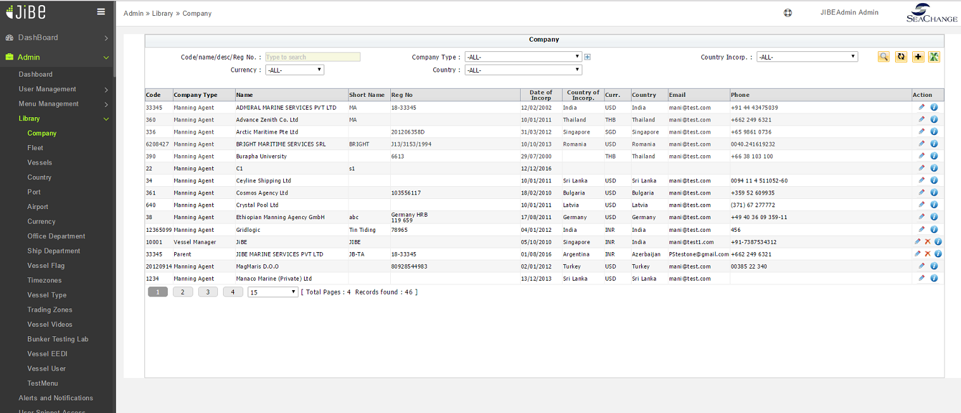

**Fig: Overall Change**

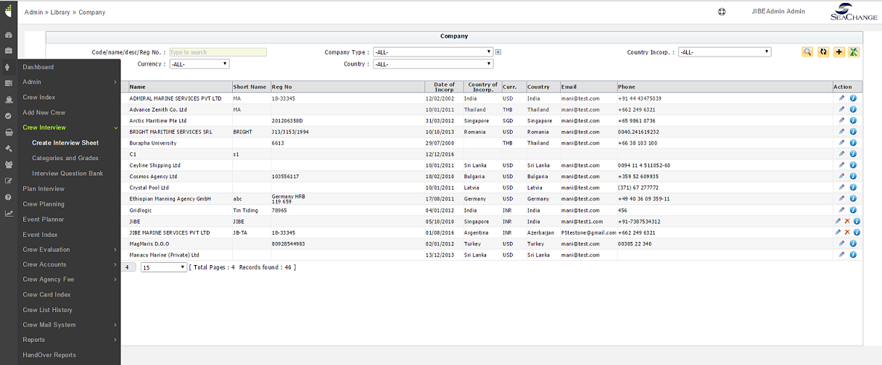

**Fig: Collapsible menu**

1. **Fixed Bugs**

**N/A**

1. **Known Issues**

N/A